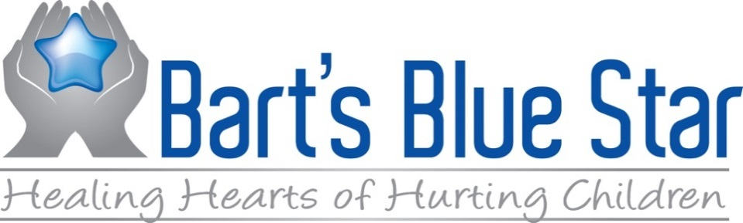

PO Box 1583
Jensen BeacH, Fl 34958
772-405-8063
Grant Application
Bart’s Blue Star Foundation’s mission is to support families, children, and adults working with children seeking support through programs that promote social-emotional growth, and the development of emotional intelligence and strategies for keeping families connected during times of loss, separation and traumatic life events.
Our primary goal is to assist not-for-profit organizations that are implementing Conscious Discipline® in the communities they serve. We do not provide direct support for instructors, nor do we conduct programs. The goal of our grant funding is to support the programs being conducted by viable entities.
We are recommending that you employ Conscious Discipline Certified instructors to provide the stated training and coaching you are seeking. All certified instructors are posted on the consciousdiscipline.com website with their contact information.
All applications are due by April 15, 2023

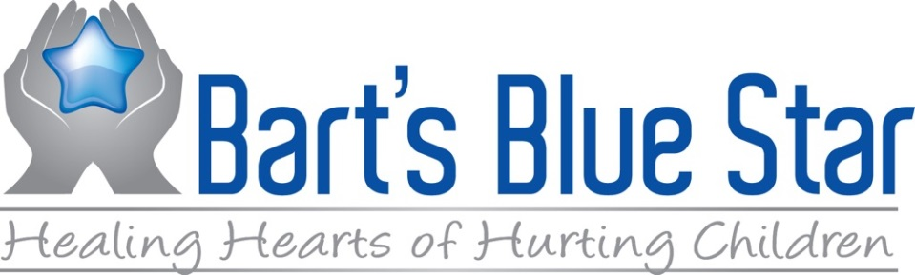

Date of Application: ______________________________________________________________
Name of Organization Requesting Funds: _____________________________________________
Is Your Organization at 501(c)(3)? Yes No
If not, what is the classification of your organization?__________________________________
Name of Project for which you are seeking funds: _____________________________________
________________________________________________________________________________
Name and Title of Person Submitting this Application: _________________________________
________________________________________________________________________________

Project Abstract:
Please describe the project (no more than one page) including the population it will serve, a brief description of the goals and objectives by which the project will be measured, and the background and qualifications of the applicant to deliver this project.

Statement of Need:
Describe the problem that the project will address, including the demographics of the population that will be served.

Project Description:
Describe the project or program, how it will be implemented, what will be accomplished and what the desired outcome(s) will be.

Project Budget:
Please attach a budget and include the cost of the entire project including the other funding sources and how much of the cost will be supplemented by this grant. Please note that the Foundation will pay no more than 50% of the cost of the project.

